APPLICATION FORM

POSITION APPLIED FOR
Internal Candidate |  | Yes/No |  | External Candidate | Yes/No |  |  |  |  |  | Where did you first see this vacancy advertised?

1. PERSONAL DETAILS
Title |  |  |  | Surname |  |  |  |  |  |  | First name
Preferred name |  |  |  |  | Contact phone no. |  |  |  |  |  | Mobile:  Home:
Address
Email
National Insurance Number |  |  |  |  |  |  |  |  | Dates unavailable for interview

If offered the position would you wish to continue to work in any other capacity? Yes /No

Please provide details?

2. REHABILITATION OF OFFENDERS
Do you have any convictions or cautions (excluding youth cautions, reprimands or warnings) that are not ‘protected’ as defined by the Ministry of Justice?
Yes / No - If “Yes”, please describe the offence and date of conviction

The amendments to the Rehabilitation of Offenders Act 1974 (Exceptions) Order 1975 (2013 and 2020) provides that when applying for certain jobs and activities, certain convictions and cautions are considered ‘protected’. This means that they do not need to be disclosed to employers, and if they are disclosed, employers cannot take them into account.
Guidance about whether a conviction or caution should be disclosed can be found on the Ministry of Justice website.

3. RELATIONSHIPS
Are you related to any Board member or Employee of this Chamber? If yes, please give details (name, position held, and relationship). Please note that canvassing of Board Members or Managers will lead to disqualification from this process..
Yes / No – Details:

Have you previously been employed by Cumbria Chamber? |  |  |  |  |  |  |  | Yes / No
We are proud to be a Disability Confident Leader employer. As part of this we offer a guaranteed interview to anyone meeting the minimum criteria for the role who has a disability or long term health condition. Do you wish to request an interview under this interview guarantee? |  |  |  |  |  |  | Yes / No

If you have a disability/long term health condition, would any support or reasonable adjustments enable you to take part in the selection process more equitably or to carry out the duties of the post? If so what? If you’d like to talk about how we can best make adjustments please call Suzanne Caldwell on 078725 050 298.
As a proud supporter of the Armed Forces Covenant we offer a guaranteed interview to service leavers who meet the minimum criteria, and welcome applications from spouses/partners. Have you or your spouse/partner served in any of the British Armed Forces? |  |  |  |  |  |  | Yes / No OR Partner Yes / No
Are you the spouse/partner of someone who is relocating to join North Cumbria Integrated Care in one of their hard to fill posts? See https://www.ncic.nhs.uk/careers/help-relocate for more information. |  |  |  |  |  |  | Yes / No – if “Yes” please give details

4. RIGHT TO WORK IN THE UK
Are there any restrictions to your residence in the UK that might affect your right to take up employment? |  |  |  |  |  | Yes / No - If “Yes” please give details
Do you need a work permit to work in the UK? |  |  |  |  |  | Yes / No

5. REFERENCES
Please give two referees who can comment on your professionalism / work ability, one of whom should be your present / most recent employer.
Do you explicitly consent to us contacting referees after you have been conditionally offered a post and have verbally accepted the position? |  |  |  |  |  |  |  | Yes / No
You should be aware that as the posts often handle sensitive data they are subject to a public disclosure, any offer of employment within The Cumbria Chamber is subject to receipt of satisfactory disclosure checks.
Reference 1 |  |  |  |  | Reference 2
Name & Title |  |  |  |  | Name & Title
Job title |  |  |  |  | Job title
Organisation |  |  |  |  | Organisation
Address |  |  |  |  | Address
Email |  |  |  |  | Email

6. EDUCATION
School |  |  |  |  |  |  |  |  | Qualifications Gained
Do you hold a driving licence?  Please provide further details if this is required for the position, including any current endorsements. |  |  |  |  |  |  |  |  | Yes / No  Endorsements:

7. PROFESSIONAL QUALIFICATIONS / MEMBERSHIP OF PROFESSIONAL BODIES
Full Details of Professional Qualifications and the date you achieved them. We encourage you to include all of your qualifications (for example they may not be directly work related – First Aider, Languages)
Qualification
Date Studied |  |  |  |  |  |  |  |  | Where studied
Qualification
Date Studied |  |  |  |  |  |  |  |  | Where studied
Qualification
Date Studied |  |  |  |  |  |  |  |  | Where studied
Qualification
Date Studied |  |  |  |  |  |  |  |  | Where studied
Qualification
Date Studied |  |  |  |  |  |  |  |  | Where studied

8. CURRENT EMPLOYMENT
Are you currently Employed ☐ or Unemployed ☐ (if unemployed give details of last employment below)
Name of employer
Address
Job title
Date Appointed |  |  |  |  |  |  |  |  | Reason for leaving
Latest Salary/Scale |  |  |  |  |  |  |  |  | Length of notice
Summary of main duties / purpose of job. Please also include your key achievements.

9. PREVIOUS EMPLOYMENT

Starting with the most recent. Please cover the last 10 years. Continue a separate sheet if necessary.
Name of employer
Job Title
Final salary/Scale
Reason for leaving
Period of Employment | Month and Year: | To | Month and Year:
Name of employer
Job Title
Final salary/Scale
Reason for leaving
Period of Employment | Month and Year: | To | Month and Year:
Name of employer
Job Title
Final salary/Scale
Reason for leaving
Period of Employment | Month and Year: | To | Month and Year:
Name of employer
Job Title
Final salary/Scale
Reason for leaving
Period of Employment | Month and Year: | To | Month and Year:
Name of employer
Job Title
Final salary/Scale
Reason for leaving
Period of Employment | Month and Year: | To | Month and Year:
Name of employer
Job Title
Final salary/Scale
Reason for leaving
Period of Employment | Month and Year: | To | Month and Year:
Name of employer
Job Title
Final salary/Scale
Reason for leaving
Period of Employment | Month and Year: | To | Month and Year:

10. REASONS FOR APPLYING
Please explain why you are applying for this post.

11. RELEVANT EXPERIENCE / SKILLS
Please give details of any achievements, career plans or particular areas of work experience (including voluntary work), which you feel are most relevant to this post. Continue on a separate sheet if necessary.

12. INTERESTS / LEISURE ACTIVITIES

13. GDPR
The Chamber complies with the General Data Protection Regulation (EU) 2016/679 and the Data Protection Act 2018. The information provided will be held securely for the purpose of administering your application and any subsequent work. Your personal information will not be used for any other purpose but may be shared with third parties if the post applied for is externally funded and the funding body is active in the recruitment process. Applicants should read the Chambers Job Application Privacy Notice, which is available on www.cumbriachamber.co.uk or on request.

14. DECLARATION
I declare to the best of my knowledge the information on this application is true and accurate. I understand that any false statements or failure to disclose any information requested on this form may result in my application being disqualified. Discovery after appointment may lead to dismissal without notice or disciplinary action.

I have read the Chamber’s Privacy Notice and understand how and why my information will be processed for the purpose of the recruitment process, and I understand my rights associated with the Chamber processing my personal data.
Signed |  | Date
Please note that if application is sent by email you will be required to sign form if selected for interview.

Your completed application form should be returned via email to suzanne@cumbriachamber.co.uk or by post to Suzanne Caldwell, Cumbria Chamber of Commerce, Broadacre House, 16-20 Lowther Street, Carlisle, CA3 8DA.
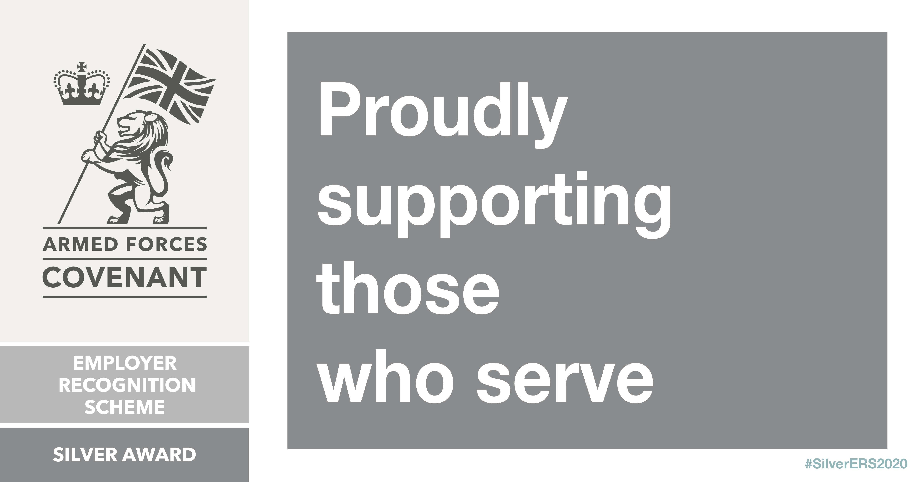
DIVERSITY MONITORING
We monitor our recruitment processes to ensure that all applicants are fairly assessed and that we meet our obligations under the various Acts of Parliament and related Codes of Practice concerning equality. We are also a committed Disability Confident Leader. Please help us to carry out this monitoring by answering the questions below. They are placed on a separate page to the application form to emphasise that they relate only to monitoring. This page will be detached and will not form part of the selection procedure. Data will be used for statistical purposes, and if successful will be held on your personal record. Please tick appropriate boxes.
EQUAL OPPORTUNITIES MONITORING

Full Name:

National Insurance Number
Sex
 | ☐ | Male | ☐ | Female | ☐ Non-binary | ☐ Other | ☐ Prefer not to say
Gender Is your gender identity the same as the gender you were assigned at birth?
 | ☐ | Yes | ☐ | No | ☐ | Prefer not to say
Preferred Title
 | ☐ | Mr | ☐ | Mrs | ☐ | Miss | ☐ | Ms | ☐ | Other – please specify
Relationship Status
 | ☐ | Married | ☐ | Single | ☐ | Separated | ☐ Divorced
 | ☐ | Civil Partnership | ☐ | Co-habiting | ☐ | Widowed | ☐ Prefer not to say
Ethnic Origin (Please tick the box that you feel best describes your ethnic origin)
 |  | White: |  |  |  | Asian/Asian British:
 | ☐ | British (English, N Irish, Scottish, Welsh) |  |  | ☐ | Indian
 | ☐ | Irish |  |  | ☐ | Pakistani
 | ☐ | Gypsy or Irish Traveller |  |  | ☐ | Bangladeshi
 | ☐ | Any other white background (please specify) |  |  | ☐ | Chinese
 |  |  |  |  | ☐ | Any other Asian background (please specify)
 |  | Mixed/Dual Heritage:
 | ☐ | White & Black Caribbean |  |  |  | Black/Black British:
 | ☐ | White & Black African |  |  | ☐ | Caribbean
 | ☐ | White & Asian |  |  | ☐ | African
 | ☐ | Other mixed background (please specify) |  |  | ☐ | Any other black background (please specify)
 | ☐ | Prefer not to say
Nationality:
Disability Do you consider yourself to have a disability/impairment under the Equality Act 2010?
(See Note 1 overleaf)
 | ☐ | Yes | ☐ | No | ☐ | Prefer not to say

Age Range
 | ☐ | 16-24 | ☐ | 25-34 | ☐ | 35-44 | ☐ | 45-54 | ☐ | 55-64 | ☐ 65+
 | Date of Birth
Faith/Religious Belief
 | ☐ | Christianity | ☐ | Buddhism | ☐ | Hinduism
 | ☐ | Judaism | ☐ | Islam | ☐ | Sikhism
 | ☐ | No religion | ☐ | Other religion | ☐ | Prefer not to say
Sexual Orientation
 | ☐ | Heterosexual | ☐ | Homosexual | ☐ | Bisexual
 | ☐ | Other | ☐ | Prefer not to say

NOTE 1: Criteria for classification as disabled under the Disability Discrimination Act

Equality Act 2010 defines that a person has a physical or mental disability/impairment if it has a substantial and long-term adverse effect on his / her ability to carry out normal day to day activities.

Long term is usually defined as a year or longer.

Impairment may affect mobility; manual dexterity; continence; ability to lift, carry or otherwise move everyday objects; memory or ability to concentrate, learn or understand; perception of the risk of physical danger; speech, hearing or eyesight. (Please note if a person’s sight is corrected by wearing spectacles or contact lenses, this is not regarded as a disability.)

These notes are for guidance only.

--------------------------------------------------------------------------------------------------------------------------------------

Data Protection
The information you supply on the application form will be used to assess your suitability for the post applied for (or another relevant post). These details will only be disclosed to those persons involved in the selection process or HR & Payroll administration.

The Chamber will retain the forms of unsuccessful applicants for 6 months, or for as long as required by funders where the role is fully or part funded by public funding.

Should you be successful, certain details from this form may be checked, and data matched to help prevent fraud. Some of the information will be entered into the Chamber’s computer system, which will allow us to administer your employment. This form will be placed into your personnel file and retained until after you complete your employment with us and retained for as long as legislation requires or as required by funders where the role is fully or part funded by public funding (whichever is the longer).

Please be assured that we will protect your information and treat it as confidential at all times. Please read the Privacy notice for more information regarding what we do with your data.

